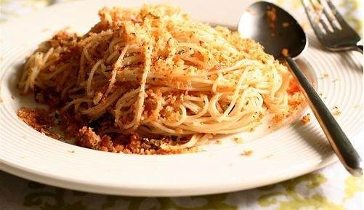Pasta con acciughe e mollica di pane
Spaghetti with anchovies and bread crumbs
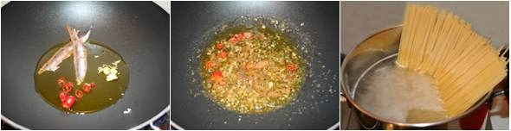

Ingredients for 4 persons
- 6 salt-packed anchovies or 12 best-quality anchovy fillets in olive oil (see Notes), divided
- spaghetti
- 1/2 cup extra-virgin olive oil
- 2 large garlic cloves, minced
- 1 or 2 small fresh or dried hot red chiles such as peperoncini thinly sliced
- 2 tablespoons minced fresh parsley
- 1/2 cup toasted fresh bread crumbs, divided

Preparation
- If using salt-packed anchovies, rinse them under cold water. With your fingers, pry them open along the back and lift out backbone in order to obtain 2 fillets. Rinse fillets again to remove any fine bones; pat dry on paper towels. If using anchovy fillets in olive oil, lift out of jar or tin, leaving oil behind. Finely chop 6 fillets; set aside. Cut remaining 6 fillets into 4 or 5 pieces each; set aside.
- Cook spaghetti in a pasta pot of boiling salted water till 'al dente', about 10 minutes.
- Meanwhile, put olive oil, garlic, finely chopped anchovies, and chillies in a deep frying pan or wide pot and cook over low heat, stirring, until anchovies dissolve. Stir in parsley and remaining anchovies; turn off heat.
- When pasta is almost done, set aside 1 cup of the cooking water, then drain pasta and transfer to pan of anchovy sauce. Toss quickly until all the strands are well coated. Add some reserved cooking water if pasta seems dry. Set aside 2 tbsp. bread crumbs, then add remainder to pasta and toss again.
- Add some reserved bread crumbs and serve immediately.
Note: Italian grocers sell salt-packed anchovies which are more flavourful than oil-packed.
This is a traditional recipe at Xmas.
M.Rosaria Molinaro II E

