Cod with potatoes and black olives
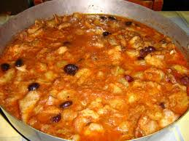
- 1 kg of dried cod sponged
- 200 gr of peeled tomatoes
- 1 red onion
- potatoes
- extra virgin olive oil
- dried oregano
- 2 basil leaves
- bay leaves
- black olives q.b.
- ½ cup of water
Cut the onion and fry with the garlic in the olive oil over moderate heat until the mixture is pale golden. Peel potatoes, wash and cut them into 1/4-inch-thick slices. Add them to the pan along with the peeled tomatoes, basil, oregano, bay leaves and half a glass of water and let it evaporate. Then put the pieces of cod, cover and cook for about 15 minutes. Turn off the flame, add the black olives, the chili and serve hot.
Rosaria Pulice IID

