Tortino Calabrese: Calabrian Pie
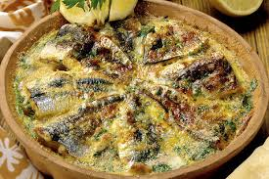 Ingredients:
500g of fresh anchovies ,
400g of peeled tomatoes,
3 eggs,
slices of sandwich bread,
2 tablespoons of bread crumbs
2 tablespoons of grated cheese,
a bunch of basil,
a bunch of parsley,
oregano,
a clove of garlic,
extra virgin olive oil,
salt.
Preparation.
Eviscerate anchovies, remove the bone and open them without separating the two halves. Chop the basil, parsley, oregano, garlic, then mix them to the grated cheese and breadcrumbs. Grease a baking pan with oil and place a layer of slices of sandwich bread without the crust, lightly sprayed with oil . On bread make a layer of sieved tomato and one of chopped herbs. Cover with a layer of fish and repeat the layers in the order so that the fish reach almost the edge of the pan, then add tomatoes, pour the beaten eggs and sprinkle with chopped herbs. Pour some oil and bake in preheated oven at 190 degrees for about 30 minutes. This cake should be served hot. (Preparation time: one hour).
An alternative of this recipe is without tomato sauce and use bread crumbs instead of the slices of bread. Mariafrancesca Mirabelli III C

