STOCKFISH at CALABRESE WAY
Ingredients:
800 gr. Of soaked stockfish ; 800 gr. of potatoes ; 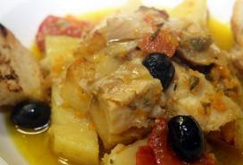 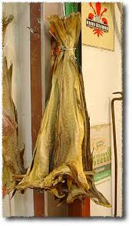
1 dl. of oil of olive , tomato paste, black olives
1 onion, garlic clove, pepper, basil, parsley
Preparation
Because the stockfish is dried, it needs to be soaked in water for 24 hours before cooking. Once done, clean it, squeezing out any excess of water. Boil the stockfish for 30 minutes, drain, dry with delicacy, remove all the skin and scales and cut into pieces. Peel potatoes, wash and cut into slices. Heat the oil in a large pan, add the onion, garlic and parsley and cook until they have softened . Add the pieces of cod , sprinkle with white wine, then leave it to evaporate. Add the tomato sauce , mixed with water or broth, and finally potatoes. Taste with basil, salt and pepper and bake for 30 minutes. Once potatoes are almost cooked, add the pitted olives and cook for another 10 minutes. Serve hot.
Food history: Stockfish, or dried cod, is commonly associated with Scandinavia. The importance of stockfish in Italy dates back to the 15th century when a Venetian navigator, Pietro Querini, was shipwrecked and ended up on the Norwegian island of Rost.
The captain and his crew came into contact with the islanders who were used to drying cod in the sun and wind so that it would last for a long time. Impressed by the flavor and convenience of the stockfish, Querini decided to bring some stockfish with him when he returned to Venice 8 months later. It is the beginning of a long commercial relationship. Still today, 90% of the stockfish produced in the archipelago of Loften is imported into Italy.
Belmonte Giuseppe IIC

